Scatterplots
Insert -> Charts -> Choose a scatteplot that you like.
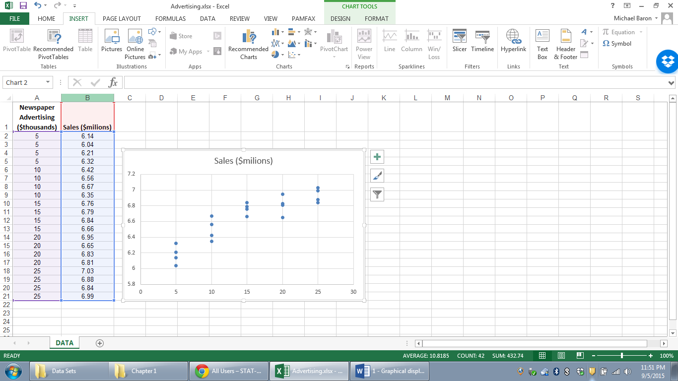

Regression
The fastest way is with the Analysis Toolpak:
2. Choose Data Analysis
1. Choose Data
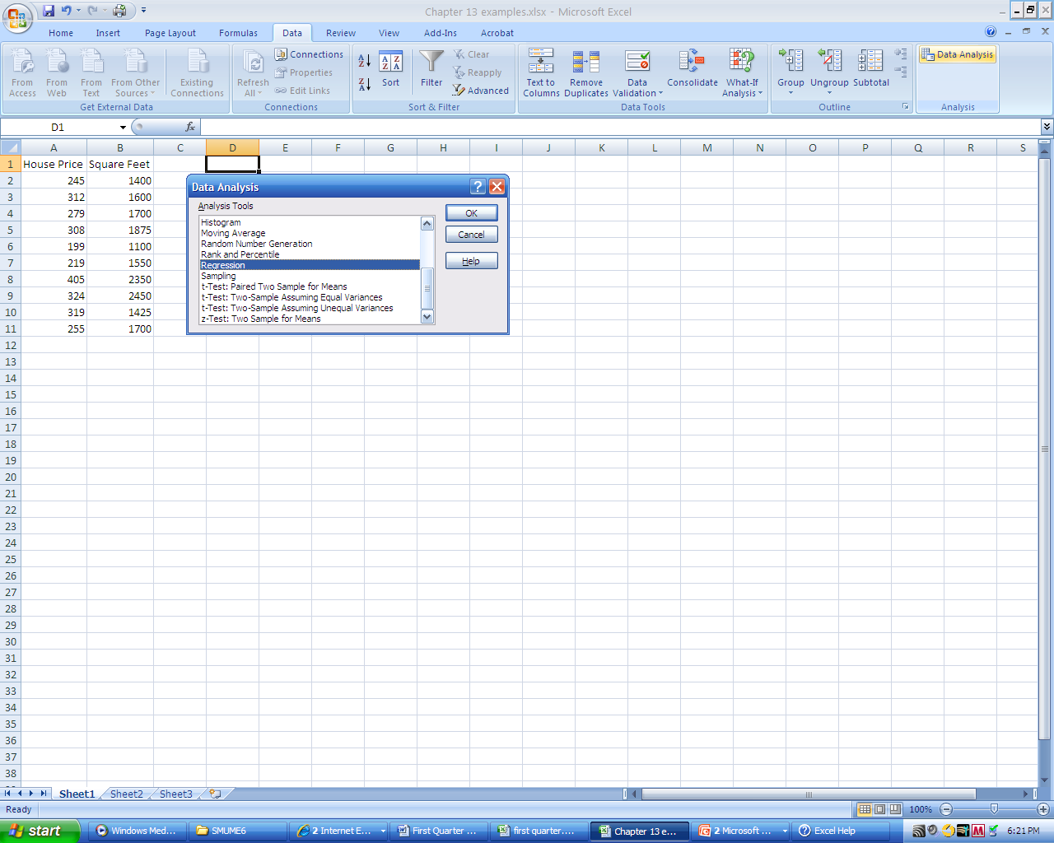
3. Choose Regression

Enter the Y range and the X range and the desired options.
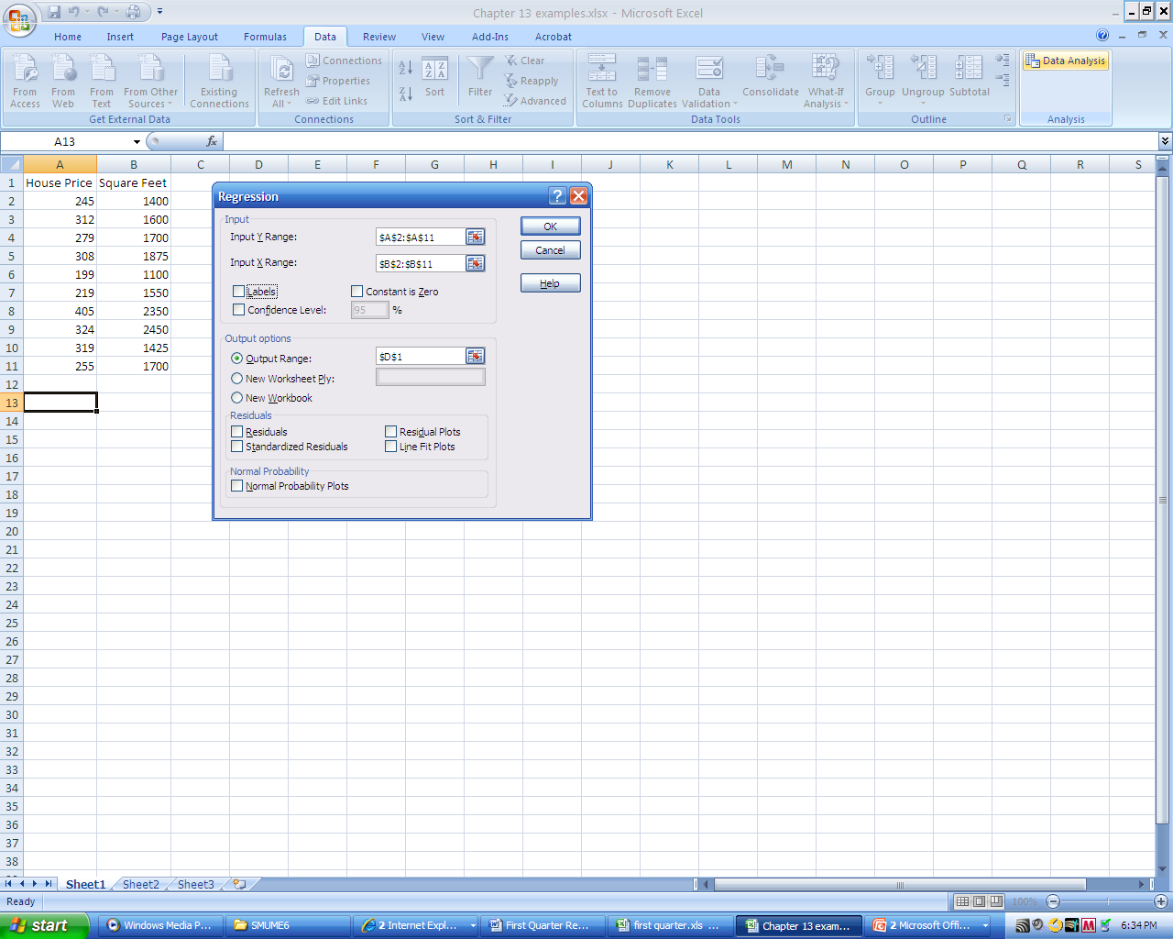
Read the output.
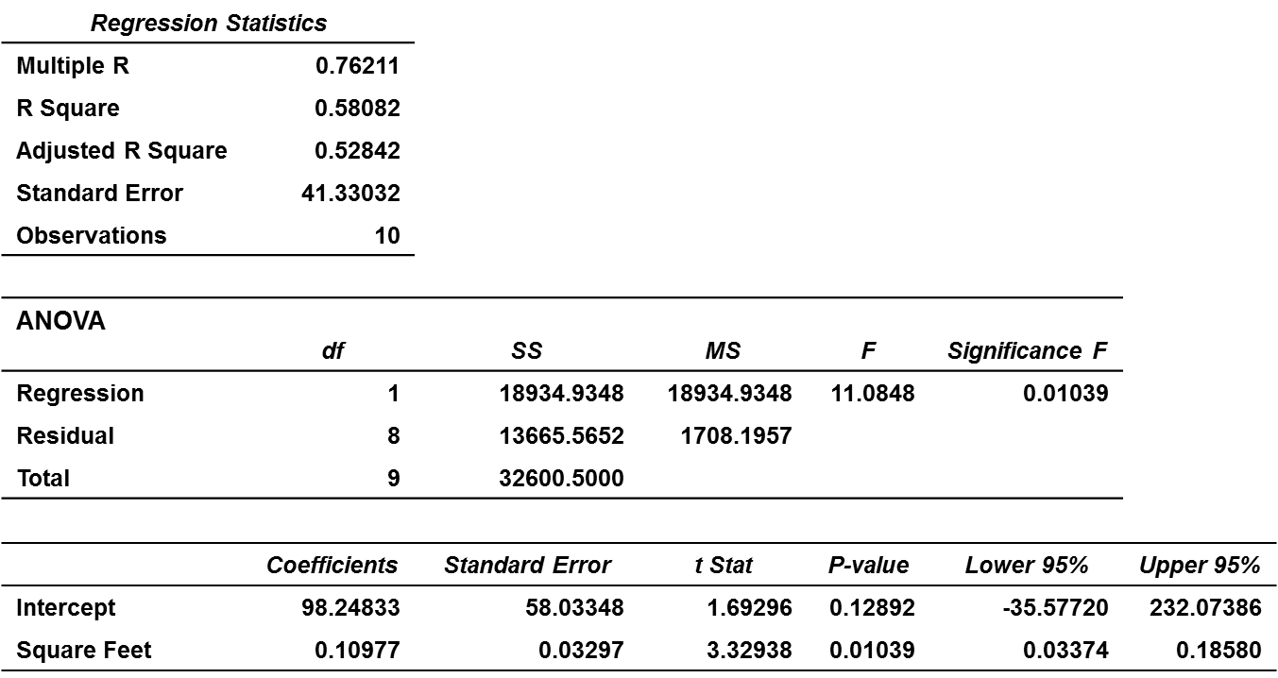

According to these results, the regression equation is
Predicted House Price = 98.24833 + 0.10977 * Area in square feet
The R² is 0.58082.
The sums of squares, associated degrees of freedom, F-statistic, and its p-value are given in ANOVA. Here, F=11.0848, and the p-value is 0.01039 (always one-sided, right-tailed in the ANOVA F-test).
Coefficients (intercept b₀=98.24833 and slope b₁=0.10977) are followed by their standard errors, t-statistics for testing
H₀: β₀=0 and H₀: β₁=0, the corresponding p-values, and finally, 95% confidence intervals for β₀ and β₁.

The toolpak can also produce the fitted line plot, if you check the corresponding box.
Intercept
= 98.248
Slope
= 0.10977

Without the Data Analysis Toolpak, Excel has functions
= SLOPE (A:A, B:B) for the slope and = INTERCEPT (A:A, B:B) for the intercept.

Correlation
Excel function =CORREL ( column X, column Y )
computes the correlation coefficient between X and Y.
11
The data analysis toolpak also has a function Correlation.

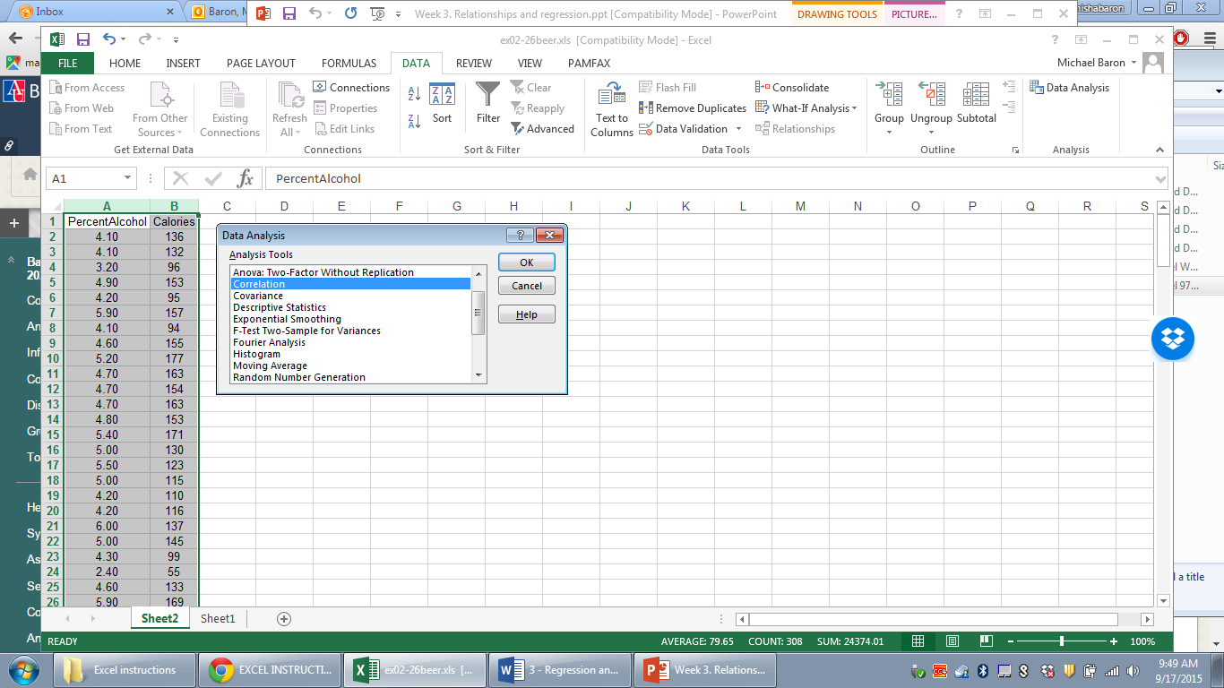
The obtained correlation matrix contains correlation coefficients for each pair of variables.
